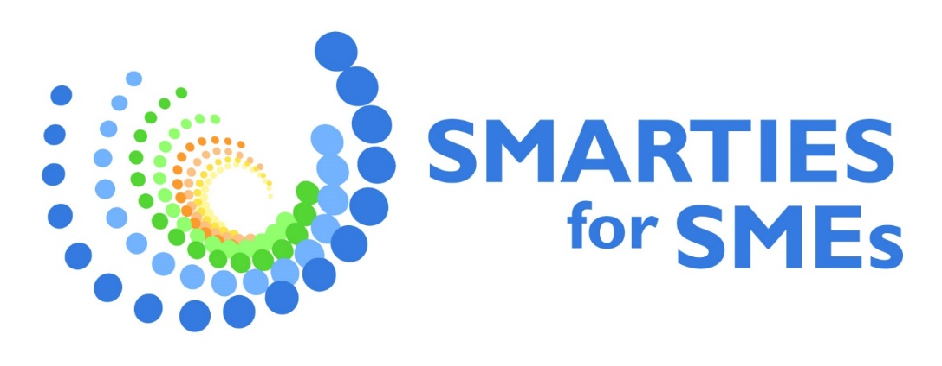
Annex II A - Application Form

INFORMATION ABOUT THE APPLICANT ORGANIZATION
The information in this questionnaire will be shared with the members of the Evaluation Committee only for assessing the application.

I, the undersigned, Legal Representative

Name and Surname

On behalf of:

1. Legal Name of the Applicant organization:

2. Applicant website and/or Social Media channel (If not available please write N/A):

3. Operating Country (tick the corresponding):

Italy | Greece | Portugal  Region of Madeira | Slovenia | Cyprus

4. Legal office (indicate full address: street, region, and country):

5. Operating office (indicate full address: street, region, and country):

6. Contact person for the project:

Name and Surname:

Position:

e-mail and phone number:

7. Who is applying?

□ single SME

□ Partnership of SMEs (2 to 4 SMEs)

□ Mixed Partnership (2 to 4 partners, of which at least 1 SME)

8. Please provide the following information on the Applicant and partners (in case of partnership)
 | Name | Type | Size and NACE code (if SME)* | VAT or registration number
Applicant |  | SME, public organization, association, other…

Partner n° 1

Partner n° 2

Partner n° 3
* For the sake of this call, tourism SMEs may belong to any NACE classes and categories, provided that their activities are relevant to the tourism ecosystem.

9. Brief presentation of the Applicant organization and partnership (economic activity in tourism, mission and vision, main goals for the future and identification of existent challenges of the business):

Max 5 000 characters

If the Applicant is a SME, please check that you comply with the following declaration:

10. I declare that:

□ The SME can be considered as such if complying with the European Commission Recommendation 2003/361/EC and the SME qualification guide.
□ The SME does not have convictions for fraudulent behaviour, other financial irregularities, unethical or illegal business practices
□ The SME has not declared bankrupt or have initiated bankruptcy procedures.
□ The SME is not under liquidation or is not an enterprise under difficulty according to the Commission Regulation No 651/2014, art. 2.18.
□ The SME is not excluded from the possibility of obtaining EU funding.
□ The SME operates with the exceptions and within the limits expressly provided for by the application of the "De Minimis" Regulations

11. Privacy regulations
I, the undersigned/a ___________________________________________ declare that I have read the information pursuant to art. 13 of the EU Regulation 2016/679 (referred to in Art. 10 Processing of Personal Data of the Call), published on the project website www.smartiesforsmes.eu and in this regard specifically and freely give my consent to the processing of personal data for the purposes indicated to be able to participate in the Call for Innovative Project.

Signature of the Legal Representative of Applicant Organization

INFORMATION ABOUT THE PROJECT

Project Summary (in English or national language)

Max 5 000 characters
Please copy here the project summary in English you provided in Part A (online), or translate it into your national language.
Be aware that it will be published and publicly used at national and European level in case you are awarded.
To help you write it, consider the following questions:
How does you project addresses the SMARTIES for SMEs thematic areas?
What kind of innovation does your project bring to the tourism ecosystem?

What activities are you going to implement and what results do you expect from them?

C1. Relevance
1.1 Select the thematic area(s) your project addresses and describe how the proposal is relevant to them.
Be aware that you need to select at least one of the specific thematic areas as core subject your project refers to. You may well select more than one specific thematic area and explain how your project refers to them.

□ Twin transition | □ Regenerative tourism | □ Synergy with agri-food ecosystem
Projects and solutions that support the twin transition of tourism SMEs, enhance their own resilience and the sustainability of the EU tourism ecosystem.  e.g. proposals that include digital solutions and training for SMEs; SMEs obtaining sustainable certifications or labels; SMEs reducing their environmental impact, etc. | Projects and solutions that develop and promote a tourism offer that respects the authenticity of the local territory and contributes to the wellbeing of local communities.  e.g. proposals that integrate regenerative tourism concepts; actively engage local communities; provide positive impact or return for the local area, etc. | Projects and solutions that develop the synergy between tourism and the agri-food ecosystem, especially promoting the Mediterranean Diet as a model of food sustainability in the tourism sector.  e.g. proposals that integrate synergies with the local agri-food ecosystem, reduce SMEs food waste, provide food sustainability certifications or processes, etc.
Max 3 000 characters | Max 3 000 characters | Max 3 000 characters

C2. Innovation
2.1 How innovative is the project compared to the present state-of-the-art and business-as-usual? What change is expected compared to the existing technology and/or solutions available in and for the tourism industry? You may relate to existing good practices.
Max 3 000 characters

C3. Quality of design
Describe the specific objectives of the project (which should be clear, measurable, and realistic) and justify how they will bring added value to the sustainability and resilience of your business and/or tourism in your destination.

Project's specific objective: The specific objective is what you and your partner want to achieve by implementing your project idea. It should contributes to the general objective of SMARTIES for SMEs (supporting tourism SMEs in the green and digital transition and promoting innovation, resilience, sustainability and quality of their tourism offer), but operating at your smaller scale and focusing on the specific challenge you want to address. It should also be measurable, i.e. defining the target it addresses and the change expected, realistic, and achievable with the financial and operational resources you have, and within the timeline expected (15 months).
e.g. 1: diversifing the tourism offer of a specific destination, introducing innovative and sustainable products (regenerative tourism, slow tourism, synergy with agri-food ecosystem, etc.) addressed to identified tourism targets...

e.g. 2: improving the sale performace in a specific destination of innovative and sustainable products (regenerative tourism, slow tourism, synergy with agri-food ecosystem, etc.) in relation to defined indicator and with a clear target...

e.g. 3: improving the digital performance of a specific destination/tourism product within an identified tourism target...

e.g. 4: reducing the environmental impact (carbon footprint/water consumption/etc.) related to a specific tourism product or process...
Describe your specific objective (only one), following the examples above. Max 2 000 characters

Activities |  | Expected result
Describe your activities and their linked expected results, following the examples below. Remember that a mix of different activities is expected as per Call. More than one activity can be linked to the same expected result. Make sure your results are verifiable. Keep in mind this question: can an outside person verify them? Max 1 000 characters each. Add lines if necessary.
e.g A1. Planning of local engagement |  | e.g. R1. Local targets are identified
e.g.A2. Workshop with local communities to identify regenerative tourism product and its characteristics (target, modality, involvement, expected return, etc.) |  | e.g. R2. New product/s is/are available
e.g. A3. Training of staff on innovative tourism offer |  | ...
A... (max 1 000 characters) |  | R... (max 1 000 characters)
A... |  | R...
A... |  | R...
A... |  | R...
Progress monitoring and reporting.
What do you expect to achieve at the different steps of the project? Please try to be as clear and concrete as possible: this will help evaluators assess your progress and also help you in monitoring your project and writing your progress reports. Add lines if necessary.
Progress step | Activities and Results achieved |  | Means of verification*
Kick-off check (after 2 months) | A... |  | Max 1 000 characters
Kick-off check (after 2 months) | R... |  | Max 1 000 characters
1st Progress Report (after 6 months)
2nd Progress Report (after 12 months)
Final Report (After the end of project)

* As means of verification for activities you can use and adapt the following examples:
- documentation that demonstrate the implementation of the activities (programmes, plans, list of attendance, reports, photos, videos etc.);
- number of participants to the activities;
- percentage of satisfaction among participants;

As means of verification for results you can use and adapt the following examples:
- Key Performace Indicators (KPI) specific for the tourism sector your organizations already use or wants to adopt (e.g. number of visitors; customer satisfaction; booking volume, occupancy rate; etc.);
- KPI related to the sustainability of the tourism offer (e.g. resident satisfaction, visitor density/flow patterns; tourism workforce satisfaction; reduction of environmental impact, etc.).

C4. Operational and financial capacity
4.1 Describe your skills and experience in implementing the project plan and list all the personnel of the team involved in the project implementation (min 1 person) in the table below. Can you demonstrate sufficient operational capacity – expertise and experience - to carry out the project? What are the skills and competences of your staff? Have you or your partners done similar projects before?
Max 3 000 characters

4.2 Describe the management structure and procedures you are going to use during the project. How are roles and responsibililties assigned to your staff and/or partners? How are you going to take decisions during the project? How are you going to monitor that the progress is in line with what you planned?
Max 3 000 characters

4.3 Describe how you propose to use the lump sum foreseen for the project (€ 25 000), in line with the information you provided in the Budget file. How are the resources allocated to your different acitivities and linked results? If you are a partnership, how do you plan to share the resources?
Max 3 000 characters

C.5 Impact and sustainability
Describe how your project contributes to the environmental, social and economic sustainability of the tourism ecosystem, considering its business potential by the end of the 15 months of duration and in the longer term.
Environmental sustainability | Social sustainability | Economic sustainability
e.g. by reducing or recycling waste, reducing CO2 emissions, water or energy consumption, use of chemical products or water pollution, etc. | e.g. by promoting social inclusion of disadvantaged citizens, residents’ engagement and support, gender equality, accessibility, better working conditions, etc. | e.g. by increasing income, visibility, positioning, competitiveness, etc.
Max 3 000 characters | Max 3 000 characters | Max 3 000 characters

How do you intend to sustain the results and impact of your projects’ solution after the grant?
Max 3 000 characters
In what way can your project serve as a good example or inspiration at local, Mediterranean and EU level? How can your solution or innovation be replicated elsewhere or scaled-up?
Max 3000 characters

Additional information

6. 1 Have the applicant or one of the partner SMEs already obtained a sustainability certification, or are you in the process of obtaining it? If so, please explain
Max 1 000 characters

6.2 Does the applicant or one of the partner SMEs include female or young people (under 40)? If so, please explain
Max 1 000 characters

6.3 Does your project promote inclusivity, accessibility and non-discrimination? If so, please explain
Max 3 000 characters

6.4 Does your project contribute to local job creation? If so, please explain
Max 3 000 characters

6.5 Does your project contribute to tourism seasonality mitigation and/or to the creation of new tourism products especially in rural/isolated areas? If so, please explain
Max 3000 characters

6.6 Is there any other relevant information you would like to share with us to support your application?
Max 3 000 characters

By submitting this application form, I acknowledge that all information provided in this application is accurate, complete, and true to the best of my knowledge. I also confirm my commitment to fully undergo all steps of the funding services.
Signature of the Legal Representative of Applicant Organization

Please upload this file in PDF Format.

State Aid “De minimis regime”: The Guidance Notice of the European Commission on the notion of “State aid” clarifies that direct funding from the European Union, including from an Executive Agency, is not considered State Aid. As a consequence, the financial distribution to third parties as an integral part of the funding granted under the SMARTIES for SMEs Single Market Programme project, funded by the European Innovation Council and SMEs Executive Agency (EISMEA), in application of the EU Financial Regulation, does not constitute “State aid” and is not to be taken into account for the calculation of the “de minimis” rule.

